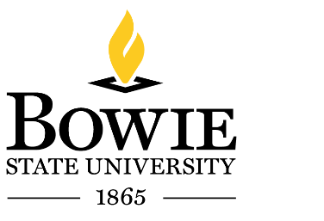
Office of Human Resources
C. Robinson Hall
T: (301) 860-3450 F: (301) 860-3453

Office of Human Resources
MEMORANDUM

To: Business Services
From: ______________________________
Office of Human Resources
Date: _________________________
Subject: New Employee Identification Card

This is to certify that, __________________________________________________ Employee ID _______________, is a new employee effective __________________.

Should you have any further questions, or need additional information, please feel free to contact the Office of Human Resources at ext. 3450.

Thank-you for your assistance.

Please Note: The employee may present this form at the Student Union first floor to obtain an Identification Card during the following hours:
Monday to Friday: 9:00 AM – 4:00 PM

