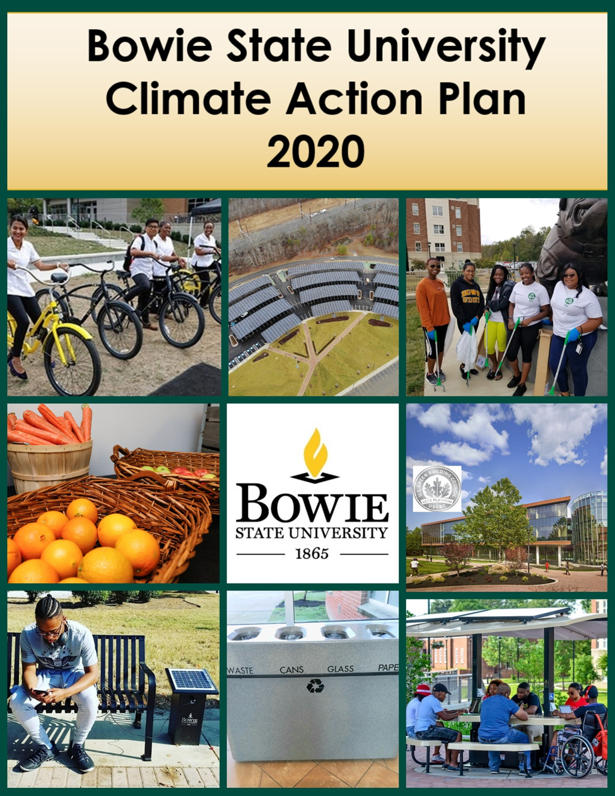
I. Background
Climate change is one of the most formative issues and pivotal movements of our time. The health of our planet is in crisis mode with no clear, unifying, global path forward. Its ramifications extend beyond science to include resilience, social justice and outright survival. We are now in a time when this can no longer be safely and comfortably ignored, and Bowie State University has taken the mission to address this at the institutional level with the goal of broadening it beyond the institution to the community level. In addition to the extremes of the current climate woes, at the time of the drafting of this document, the planet is also experiencing one of the worst pandemics, and one of the largest movements against racial and social injustice. All of these issues are incorporated into the realm and subject of sustainability. Bowie State University is deeply concerned with the scale and speed of global warming and it’s foreshadowing for large-scale, adverse health, social, economic and ecological effects.
What is climate change and its effects?
Climate change is a long-term change in the earth’s climate, especially a change due to an increase in average atmospheric temperature caused primarily by human behaviors. Current and future climate impacts put our very life, liberty and pursuit of happiness at risk. Americans are already experiencing more frequent extreme heat days, increases in wildfires that lead to poor air quality (possible higher susceptibility to COVID-19), more severe storms with long-term devastating health impacts, longer seasons for disease carrying mosquitoes and ticks, rising carbon dioxide levels meaning longer and more severe allergy seasons and less nutritious crops.
Why should Bowie State care about lessening the effects of climate change?
For one, our core values encourage us to. See below the core values of Bowie State University:
- Excellence- Fostering a stimulating learning and work environment can only be done on a clean, healthy campus with environmentally responsible stewards.
- Inclusivity- Creating a community encouraging engagement, respect and connection among campus constituents should include understanding that certain communities are disproportionately vulnerable to climate change, including low-income communities, and indigenous and other communities of color.
- Integrity- Demonstrating high ethical standards with one another and the larger community is to keep our campus clean, recycle responsibly, reuse and repurpose whenever possible, and not be wasteful of natural resources
- Accountability- Each member is expected to be responsible and accountable for the outcomes of their efforts and actions including how we respect our campus where we live, learn, and work and on the planet where we live, thrive, and are responsible for preserving
- Innovation- Encouraging students, faculty and staff to utilize best practices and pursue new opportunities is a huge part of embracing new technologies and methods to help combat the effects of climate change

In addition…
- We are an University System of Maryland [USM] institution and USM institutions are expected to be key leaders in environmental stewardship.
- Additionally, as a state supported school, we are mandated to follow certain statewide environmental guidelines, and as an institution in higher education in general we take pride in being a leader and not a follower in one of the largest social and environmental movements of our time
- Bowie State is a signatory of the Climate Commitment (2015) and the Paris Climate Agreement (2015)
- Environmental injustice and environmental racism are real in the very communities where our students and employees live or come from
- Extreme heat waves and harsh winter conditions could put strain on some of our older HVAC systems while heavy downpours, more intense and frequent North Atlantic hurricanes and the associated rainfall rates can cause more flooding to our campus infrastructure

History
Bowie State University became a charter signatory of the American College and University Presidents' Climate Commitment (now called the Carbon Commitment) in 2007 and completed its first Climate Action Plan (CAP) in the Fall, 2009. The world has seen unprecedented climate, health, civil and social changes since BSU’s original CAP and ambitious and lofty commitment to being climate neutral by 2012. An addendum was created at the end of 2017 updating each section of the original CAP. Both of these documents are located on our website at: www.bowiestate.edu/about/sustainability/climate-action-plan.php. The original CAP contained many goals, ideas and recommendations for implementation.
Achieved Accomplishments
In 2020 it is important to note that BSU has already achieved many of its original CAP goals including (but not limited to):
- Sustained commitment of its core Sustainability group, C4 (which retains longstanding members as well as students who are transient)
- Energy Performance contract was awarded (Johnson Controls)
- A sustainability fee was added (Undergraduate and Graduate students)
- Utilized energy efficient and sustainable design standards on all new construction and applicable renovation projects (after 2009)
- Increased biodiversity and usable green space of the campus while reducing dependence on fossil fuels, other extracted minerals, chemical fertilizers and pesticides
- Increased usage of hybrid and electric vehicles on fleet
- Providing shuttle bus to local entertainment and shopping to decrease individual vehicle trips
- Developed (sustainability) website
- Emphasis on curriculum to mention sustainability as a theme primarily in general education courses
- Modifications to dining service (to include trayless cafeteria and no plastic straws or Styrofoam containers)
*Visit this link on our website: https://www.bowiestate.edu/about/sustainability/accomplishments/ for more of our current Accomplishments.

II. BSU Climate Action Plan 2020 Explained
We are now at a crucial time where the university is challenged to create a NEW climate action plan. An action plan is simply a sequence of steps that must be taken, or activities that must be performed well for a strategy to succeed. Therefore, rather than producing another 40+ page document, this plan is designed to be more streamlined, yet comprehensive in nature, more concise, cover a shorter term period, and based primarily on actual actions that are taking place and/or are planned to take place within a 5 year period. This becomes the foundation for the new plan entitled ‘BSU Climate Action Plan 2020’ (BSUCAP2020). The BSUCAP2020 is formatted in two versions: 1) via Goals, and 2) via Time frame.
Explanation of Columns
Action- The tangible item, process, service, or change you plan to implement or product to procure
Supporting Goal (Spreadsheet by goal)- Many of the action items apply to more than just the primary goal, and have another goal or two that applies to the action item.
Applicable Goal (Spreadsheet by time frame)- This refers to the actual goal where the action item falls under.
Responsible Dept/s- The primary campus departments that will be responsible in carrying out the action item and/or providing major support or assistance in its implementation
Time Frame- Each action item has a semester where the action is being planned to commence, and one semester where the action is planned to end or be fully implemented. Note that some actions may not begin or end exactly during the specified season. For purposes of this plan, the periods are broken down by three seasons, which similarly follows the standard college semester:

- Fall (mid-August through December),
- Spring (January through mid-May),
- Summer (mid-May through mid-August)

Tasks- Outlining of the action steps the department plans to take to achieve the action.

Measure of Success- Quantifiable way of expressing success for each action item.
Planning Process:
The BSU Climate Action Plan task force was formed by invitation from the Vice President of Administration and Finance to representatives of various departments across campus which have a high impact on the campus sustainability efforts. The represented departments in the Task Force were: Academic Affairs, Auxiliary Services & Dining, Facilities & Grounds, Health & Wellness, Human Resources, Procurement/Transportation, Residence Life, Student Life, and Travel. This does not exclude or absolve other campus departments from being involved in the planning and implantation of the action plan. Meetings were held and assignments given.
Portions that were omitted from the published BSUCAP 2020 but are left for internal purposes were: Budget, and Obstacles. While it is difficult to ascertain the costs associated with each item, the Task Force is aware that most of these measures will cost additional monetary resources. It is presumed that the departments will be responsible for the funding and purchases needed to carry out their actions. All action items will have possible obstacles. These obstacles are noted in the internal document for the Task Force.
*The Task Force is designed to meet 2-3 times per year (or more if needed) to review and monitor the progress of the action items in the plan.

III. Goals and Objectives
Climate Action Plan Goals:
- Continue management of solid waste through:
- Reduction of paper usage
- Reduction of food waste and addressing food insecurity
- Increased recycling and/or reusing

- Increase renewable energy and energy efficiency and conservation

- Foster sustainable behavior through curriculum and training, community engagement, awareness activities and communications enhancement

- Reduce carbon footprint from transportation-related emissions

- Continue and enhance sustainable environmental and landscaping actions

Applicable Institutional and Divisional Goals/Objectives
Institutional:
- Continue to reduce the carbon footprint and develop sustainability initiatives that create significant reduction in Greenhouse Gases. Bowie State University Institutional Goals and Presidential Objectives, FY 2018
- Continue to develop a campus infrastructure that supports a commitment to eco-friendly practices in expanding facilities that enhance student development and innovative instructional practices. Bowie State University ‘Racing to Excellence’ FY19-FY24 Strategic Plan, Goal 5: Ensure Long term Viability of BSU.

Divisional (Administration and Finance):

- Make Sustainability a core part of Administration and Finance culture in support of Goal 5 in the BSU Strategic Plan. Division of Administration & Finance Strategic Plan FY 2019-June 2022, Goal 4.

- Improve campus and physical environment. Division of Administration & Finance Strategic Plan FY 2019-June 2022, Goal 5.

IV. Greenhouse Gas Emissions
The greenhouse gas (GHG) inventory was developed using the Second Nature Reporting Platform which converts GHG data into metric tons carbon dioxide equivalent emissions, or MTeCO2. The scope of the inventory included collecting data associated with electricity, fuel, air travel, fleet vehicles, solid waste & paper recycling, refrigerants and certain other chemicals associated with global warming. The new baseline for this action plan will begin with the numbers produced from 2019. The 2019 MTCO2e was 14,834 which is a 40.5% decrease from the original 2007 baseline amount of 24,907.
With a reduction goal of -2.5% per year (15% total), the new goal amount is 12,742 MTeCO2 by the year 2025.
Recycling Materials
The table (refer to page 14) shows the Recycling Act (MRA) Materials collected (in tons) for 2018 & 2019 for the categories of: co-mingled material (glass and plastic), corrugated cardboard, and white paper. The table reflects the percent change from 2018 to 2019.
All of the percentages were increased. We would like to keep up that trend of increasing the amounts of recycled co-mingled material. The year, 2019 was an unusual year for recycling corrugated cardboard. We do not expect a drastic change from year to year in this category. The University also plans to drastically decrease the overall usage of paper therefore disallowing a drastic increase in the recycling of paper, and therefore we expect that number to stay fairly stable.
With an increase goal of +3% per year (18% total), the new goal amount of co-mingled recycling material is 247.66 tons by the year 2025.
See Table 1, page 14.
V. Climate Resilience
Bowie State University recognizes the importance of addressing climate change as well as minimizing the impact it will have on the quality of life for present and future generations. Therefore, resilience is a major part of creating the Climate Action Plan (BSUCAP2020). To summarize, the IPCC defines resilience as the ability of a system and its components to anticipate, absorb, accommodate, or recover from the effects of a hazardous event in a timely and efficient manner.
Regional data indicates intense storms and precipitation will likely present as hazards of greatest concern for us. Hazards liable to adversely affect BSU include extreme storm events such as snow, ice and wind, possible heat waves and flooding. The following is a description of some of the regional impacts that have been the focus of recent studies and research.

Increasing Temperatures--- According to the National Capital Region Climate Change Report, the average temperature in the region is projected to rise by at least 2 degrees Fahrenheit by 2025. The rising temperatures will come with a significant increase in the number of heat waves that are experienced.

Changes in Precipitation Patterns---In addition to rising temperatures, climate change is also expected to bring changes to the normal precipitation patterns in the region.

Impacts on Public Heath ---- Increased public health risks are one of the biggest concerns that come with climate change. A warmer climate could result in increased cases of vector-borne diseases (e.g. Lyme disease carried by ticks), water borne disease, and heat related health issues, and respiratory problems due to poor air quality. In addition to health problems, resulting directly from extreme heat events (e.g. heat stroke) there is also a correlation between heat waves and poor air quality.

Toward this end, BSU conducted a campus assessment using Second Natures’ Campus Evaluation of Resilience Dimensions as a guideline to help assess the five dimensions of resilience to include Infrastructure, Economics, Ecosystems Services, Social Equity & Governance, and Health & Wellness. The focus of our resilience planning efforts rely heavily on infrastructure and health and wellness. See Graph 1, page 14.

Maintaining a viable infrastructure (HVAC, mechanical systems water supply, utility dependencies including refrigeration for food and medicine, aging residence halls, vulnerable trees, hazardous materials storage, and impervious ground surfaces) is essential.
Infrastructure concerns necessarily influence the health and wellness tenets of resilience. Of particular concern, are the support of campus food systems including utility dependencies and workforce support, storm water management, establishing protocols for management of widespread infectious disease, and housing and wellbeing of students. Regional transportation, information systems and networks, and support of faculty and staff during extreme weather are also of major concern.

Resilience Goals
Within the next 5 years, the University plans to implement or continue these resiliency measures:
Infrastructure
- Update mechanical, electrical, and plumbing (MEP) systems, continue to improve fresh air ventilation, and allow for better response to seasonal temperature extremes (e.g., increased heating and/or cooling capacity).
- Survey buildings to determine priority needs for upgraded systems
- Assess best systems needed for specified buildings
- RFP process for best vendors
- Select vendors and secure funding sources
- Implement work schedule for vendors and design notifications to building occupants/campus
- Work commences in buildings

- Undergo campus-wide project to replace old and leaky roofs of several buildings. New roofing technologies help balance decreased heat absorption, storm water management, and carbon-emission reducing renewable energy opportunities while ensuring durability and resilience to weather hazards, such as high wind and snow loading.
- Survey and access the existing roof
- Provide specifications for design
- Roofing contractor to remove existing roof
- Install new roof

- Increase power system reliability and renewability including investment in battery systems, appropriately placed backup/emergency generators, and update monitoring alert systems such as fire alarm and other emergency alert systems
- Determine which buildings and systems require renewability
- RFP process for best vendors
- Procure equipment
- Install workstations, gateway cards, and generators appropriately

- Significantly increase campus information technology infrastructure for support of alternative work and teaching arrangements to allow continued productivity during extreme weather or pandemic related events
- Assess the capabilities of current technology and application ERP transformation assessment readiness
- Establish plan, secure funding and develop documentation for technology infrastructure business processes and integration points
- Ensure patches/fixes, security measures are applied and implemented as required
- Purchase proper application licenses and continue enhancement of virtual technologies to sustain a stable and secure environment
- Roll out plan to refresh and renew end-of-life and out-of-support equipment

Health & Wellness
- Significantly increase campus information technology infrastructure for support of alternative work and teaching arrangements to allow continued productivity during extreme weather or pandemic related events.

For more details on the following two priority points, please refer to the BSU Emergency Management Plan
- Cultivate opportunities for BSU community to forge city and county liaisons for emergency housing of international/non-local students, volunteers to bridge language gaps in emergency services, and on-campus housing options for emergency workforce.
- Liaise with local police, fire, and EMS to ensure a high level of response in circumstances where disaster events extend beyond 24-36 hours.
Other climate resilience efforts can be found in the BSU Facilities Master Plan.

VI. BSU Climate Action Plan 2020 (not including Resilience)
Goal 1:
Continue reduction of solid waste through: (a) Reduction of paper usage, (b) Reduction of food waste, (c) Increased recycling and/or reusing.
- Reduction of paper
- Implement University wide policy to require all course syllabi to be available electronically
- Draft a general policy in a General Education workgroup
- Approval of Gen Ed curriculum committee, Faculty Senate, and Provost
- Approval by University Council and Cabinet
- New policy communicated to all Faculty members
- New policy added to University website

- Post all course and supplemental materials in Blackboard
- Draft a general policy in a General Education workgroup
- Approval of Gen Ed curriculum committee, Faculty Senate, and Provost
- Approval by University Council and Cabinet
- New policy communicated to all Faculty members
- New policy added to University website

- Significantly increase campus system of electronic forms, electronic signature to replace paper-based processes
- Identify all sources of requests that use paper forms
- Determine vendor pool, evaluate offerings
- Pilot engagement with selected vendor
- Form Selection Committee
- Evaluation and recommendations from Selection Committee
- CPIC process (DIT)
- Acquire, implement, and manage solution
- Create campaign to notify campus community of this change

- Digitalize archiving of Human Resource (HR) documents
- Identify all documents that need storage and archiving
- Determine vendor pool, evaluate offerings
- Coordinate digitalization of documents
- Documents scanned are stored for secure destruction
- Documents shredded
- Create an online booking tool for booking air travel, hotel reservations and car rentals
- Meet with Globetrotter Travel to create an online booking tool.
- Implement online booking tool
- Promote and encourage use among employees

- Reduction of food waste and addressing food insecurity
- Reduce food waste from catered events
- Identify text alert app software that allows students to sign up to be notified of catering events that have food remaining at the conclusion of the event
- Develop steps & guidelines for event holder to communicate food overage to students at event conclusion
- Develop tool for measuring student participation in program
- Work with DIT to implement to produce internal app

- Expand sustainable options in the food pantry
- Communicate with distributors to offer more fresh vegetables and fruits
- Work with retailer to obtain recycled bags and distribute recycled bags for food items

- Implement Sustainable To Go program
- Increase meal plan purchases for non-required meal plans (faculty/staff, and commuters)
- Work to increase carry out options
- Increase marketing efforts

- Allow students who may be suffering from food insecurity to obtain free meals on campus
- Create process to identify students who suffer from food insecurity
- Create system

- Increased recycling and/or reusing
- Collaborate with Follett to increase sustainability practices in campus bookstore
- Offer reusable bags for purchase and use recyclable and biodegradable bags for implementation of “Please Don’t Take A Bag Program”
- Enhance the marketing of the buyback book program
- Increase digital book options
- Increase eco-friendly gift and clothing items
- Collaborate with Procurement Services to provide electronic battery drop off in Bookstore

- Create a Recycling task force
- Create a statement of work to include the problem and timeline
- Form task force through recommendation from VP, other cabinet members, C4 and Student Life
- Hold meetings to gather recommendations
- Form and submit proposal for approval

- Place more recycle bins in the Residence Halls
- Take recommendations from task force on recycle bins for rooms and in common areas
- Purchase recycle bins for residence halls
- Renegotiate ABM contract in residence halls to allow for increase in bin collection and proper hauling.

- Expand Book Recycling
- Identify locations for collection points and persons responsible for collection
- Purchase collection bins (if necessary)
- Set up a location in the residence halls and academic buildings to collect unwanted books for recycling.

- Expand ink recycling program
- Identify locations for collection points and persons responsible for collection
- Purchase collection bins (if necessary)
- Set up ink Recycling boxes throughout the campus and keep track of the usage.
Goal 2:
Increase energy efficiency and conservation.
- Continue to retrofit building common areas with LED lighting
- Identify retrofit areas
- Purchase requisite number of bulbs
- Coordinate installation schedule with building occupants
- Install bulbs/fixtures

- Initiate program for installation of lighting sensors in common areas and hallways of residence halls
- Assessment of the most frequently used rooms or spaces in the residence hall
- Meeting with Facilities Management to ensure process of completion
- Obtain quotes from a contractor to complete the work
- Coordinate and installation of lighting sensors
- Undergo campus-wide project to replace old and leaky roofs of several buildings (also located in Resilience section)
- Survey and access the existing roof
- Provide specifications for design
- Roofing contractor to remove existing roof
- Install new roof

Goal 3:
Foster sustainable behavior through curriculum and training, awareness activities and community involvement, and enhancement of communications.
- Incorporate Faculty Institute Presentation on BSU’s Sustainability Efforts
- Establish a partnership between C4 and CETL
- Explore speakers and workshops options
- Work with Academic Affairs to place presentation/s on schedule
- Implement the option

- Create Sustainability Curriculum Component in Freshman Seminar (FRSE 101)
- Assemble a development team
- Develop module and pilot the module
- Evaluate module

- Evaluate Effectiveness of General Education’s Emerging Issue Component
- Establish a partnership between C4 and the General Education committee
- Determine who will perform study and implement study
- Report results and recommendations for improvement

- Expand Earth Day celebration to include Residence Life & Student Life
- Hold a comprehensive planning meeting
- Design what program/s and/or event/s will look like
- Delegate responsibilities
- Contact possible vendors & on campus partnerships
- Launch event

- Initiate program for mandatory Sustainability training for all Residence Life staff
- Communicate with other institutions that have or are putting this into practice
- Form a team of Residence Life staff to plan and coordinate training as well as schedule
- Add these responsibilities to the new Resident Assistant job description.
- Get approval from VP of Student Affairs

- Create a campus sustainability map
- Decide which projects should be highlighted on a campus map
- Design key for map
- Consult with URM to create a digital map of sustainability features and projects across campus

- Apply for full SGA status as a campus organization for Student Green Ambassadors
- Meet with Student Life on pros and cons of applying
- Apply for organization status

- Develop sustainability branding and logo
- Solicit student idea designs for branding and logo
- Meet with URM to propose designs
- Get approval of designs
- Enhance external community outreach efforts in sustainability
- Research local organizations, schools, and agencies active in environmental sustainability
- Respond to those orgs, schools, and agencies who have already reached out to partner with or sponsor BSU sustainability activities
- Cultivate relationships through communications, and work with on-campus groups to help collaborate with said agencies
- Coordinate, plan, attend, participate in, invite and/or co-sponsor local and community climate change or sustainability related events, panel discussions, etc

- Increase partnership opportunities in renewable energy for BSU community
- Research local organizations, schools, and agencies active in environmental sustainability
- Respond to those orgs, schools, and agencies who have already reached out to partner with or sponsor BSU sustainability activities
- Cultivate relationships through communications, and work with on-campus groups to help collaborate with said agencies
- Coordinate, plan, attend, participate in, invite and/or co-sponsor local and community climate change or sustainability related events, panel discussions, etc

Goal 4:
Reduce carbon footprint from transportation related emissions.
- Expand and enhance BSU Bike Share program
- Double the number of bicycles accessible for rental
- Expand the number of locations on campus where bicycles can be rented to a minimum of 2
- Implement technology that eliminates the need to reserve a bike with a person through the creation of an online app

- Create virtual tour for Conference & Event services to decrease in person visits
- Collaborate with URM on scope of project
- Identify key spaces on campus used for Conference & Events Services
- Coordinate opportunity to capture various layouts of rooms
- Identify independent videographer to film and edit the website
- Add photos and videos to CES webpage

- Increase permanent teleworking percentage of employees
- Communicate with other USM institutions on their telework policy
- Modify existing policy to make it more comprehensive and concise
- Get proper approval- VP of Admin & Finance, Staff Council and Union, University Council and Cabinet
- Encourage teleworking for employees
- Revise telework forms and process forms

- Develop a travel workshop presentation to educate campus on current travel policy guidelines including promotion of ways to reduce our air travel carbon footprint.
- Develop presentation to include tips on how to improve carbon footprint when flying and airlines that are the 'greenest'
- Pilot presentation & gain approval
- Coordinate presentations with Campus calendar
- Increase electric vehicle charging options on campus
- Identify personnel (Communications, Facilities,
Sustainability, Campus Safety)
- Review the plan
- Sign off on site proposal
- Allow BGE to create detailed design package & Right of way agreement
- Final design package to be signed
- Construction begins
- Meet with BGE to determine plan

Goal 5:
Continue sustainable environmental and landscaping actions.

- Create and sustain campus garden
- Identify a space on campus in which the garden can be planted
- Engage expert horticulturist to ensure long term viability of garden
- Create a BSU Garden Club
- Create activities around planting and use of items grown in the garden
- Ensure there is minimal food waste from garden items
- Collaborate with Wellness Center, Facilities Management, and University Advancement
- Create and plant garden

- Create compost heap to create organic fertilizer
- Find location and create shallow trench
- Lay landscape fabric and borders in trenched area
- Dump; landscape debris in the trench out as landscape work progresses creating a compost heap
- Regularly turn the debris using the backhoe

- Plant additional trees on campus (20-30)
- Apply for funding with agency/agencies
- Identify spaces on campus where additional trees can be planted
- Get final approval from Facilities and VP (Admin & Finance)
- Coordinate site visit with appropriate agency
- Coordinate irrigation system and installation
- Schedule, plan, and promote planting event
- Planting of trees

- Initiate a comprehensive BSU ‘Keep our Campus Clean’ & Recycle campaign
- Collaborate meeting with C4, Res Life and Greek Life
- Create draft proposal and obtain approval of VPs
- Create a leadership group of students from various entities
- Create short video for clean up
- Create short video for Recycling
- Meet with URM for any advice, pointers, roll out methods, and branding
- Create promotion through other various sources of media
- Rollout of new campaign
- Create rain barrel system for landscaping
- Find appropriate campus locations
- Select most efficient barrels for our campus and purchase
- Systematically place barrels in the designated areas
- Connect barrels overflow hoses appropriately

 | Co-mingled (glass, metal, and plastic containers) | % difference (co-mingled) | Corrugated cardboard | % difference (cardboard) | White paper | % difference (white paper) | Total of all material | % difference (all material)
2018 | 178.60 | N/A | 1.60 | N/A | 16.95 | N/A | 197.92 | N/A
2019 | 188.59 | +5.6% | 4.00 | +150% | 17.00 | 0.3% | 209.88 | +6%
Table & chart.

Table 1.
Recycling Material (in tons)

Graph 1.
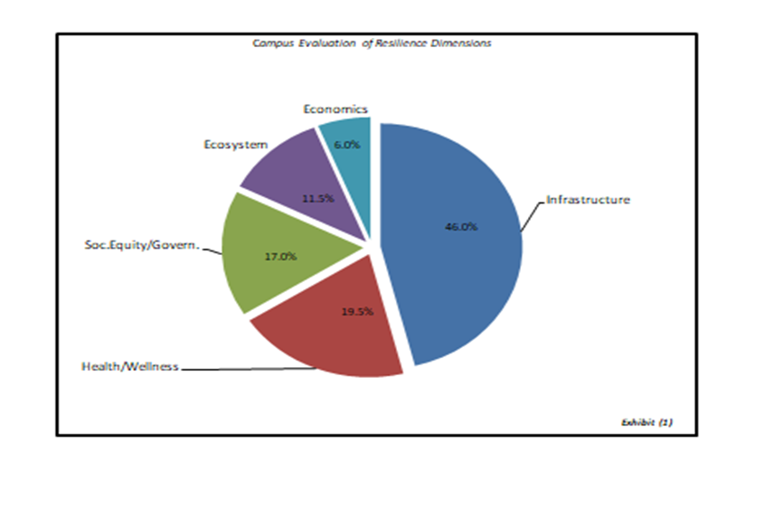

Bowie State University Climate Action Plan Task Force members:
[* symbol represents C4 member; Italicized member represent consulting member]
*Jabari Walker ……………………………………………………. Chair (Admin & Finance)
Charles Adams …………………………………………………… Academic Affairs
*Patricia Hughes ………………………………………………...... Academic Affairs
Dawnita Smith …………………………………………………..... Dining/Auxiliary Services
*Jacqueline Jackson-Palmer ……………………………………… Facilities/Grounds
Rita Wutoh ………………………………………………………... Health & Wellness
Deborah Humphrey ………………………………………………. Human Resources
Vernon Jones ……………………………………………………………. Information Technology
Salvador Martinez ……………………………………………….. Procurement/Transportation
Michael McNeil …………………………………………………. Residence Life
Thomasina Boardley ……………………………………………… Student Life
Renee Myers …………………………………………………….. Travel

Bowie State University Administration (2020-2021)
Dr. Aminta Breaux ……………… President
Dr. Carl Goodman …..……….….. Provost & Vice President for Academic Affairs
Karen J,Shaheed, Esq …..……….. Executive Vice President & General Counsel
Kimetta Hairston …..………..…… Special Assistant to the President for Strategic Engagement
Anthony Savia …………………… Vice President for Administration & Finance
Dr. Brian Clemmons …………….. Vice President for Enrollment Management
Marivic Weiss …………………… Interim Vice President for Information Technology
Brent Swinton …………………… Vice President for Institutional Advancement
Dr. Demetrius Johnson …………… Vice President for Student Affairs
Clyde Doughty ……………………. Vice President for Intercollegiate Athletics and Recreation
Cassandra Robinson ……………… Director of University Relations and Marketing

C4
The Bowie State University C4 (Climate Commitment Coordinating Committee) is comprised of students, faculty, and staff. A current list of committee members is found on our website.

ACKNOWLEDGEMENTS
The Division of Administration and Finance and Sustainability Officer would like to express gratitude to the many campus departments in helping to develop and implement these strategies and for everything else they do to make Bowie State University a model among Maryland and other national institutions in sustainable actions.
- Auxiliary and Dining Services
- Division of Information Technology
- Campus Safety
- Facilities Management
- Greek Life
- Health & Wellness
- Human Resources
- Procurement
- Residence Life
- Student Life
- Transportation Services
- University Relations and Marketing
We would also like to thank our external partners for helping Bowie State University to achieve these goals. This list may not include every company or vendor.
External Partners
- ABM
- Johnson Controls
- Aladdin Foods
- Baltimore Gas & Electric

