ILLiad guide - making an ILL request - using ILLiad (Interlibrary Loan internet accessible database)
Login to your ILLiad Account- Do you have an account? If not – click on First Time Users
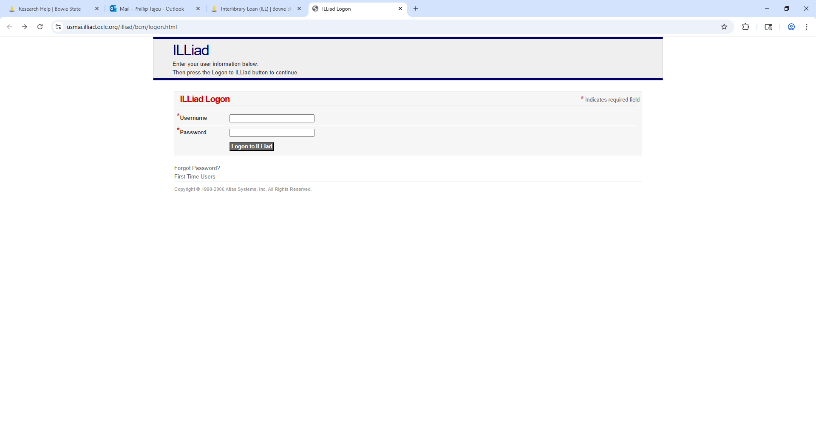
a). Username - enter the 14-digit Lib# on your Bulldog Card
b). Password - anything you want – preferably - your Last Name
Login failed. Please check your username and password before trying again
or click on Forgot Password or First Time User

- Forgot Password? Enter your username. Click Reset Password. Receive email to reset password
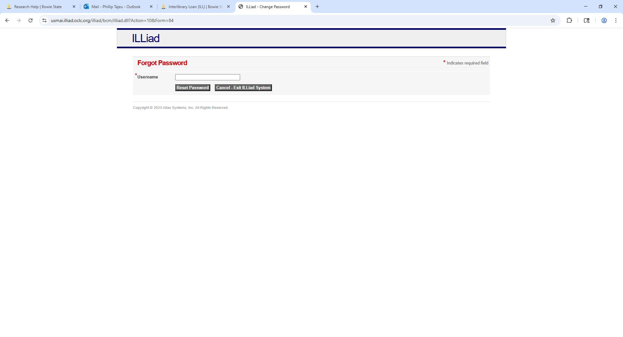
If the email you specified exists in our system, we have sent a password reset link to it.

- First Time Users follow the instructions below. Scroll down and click on First Time User Click Here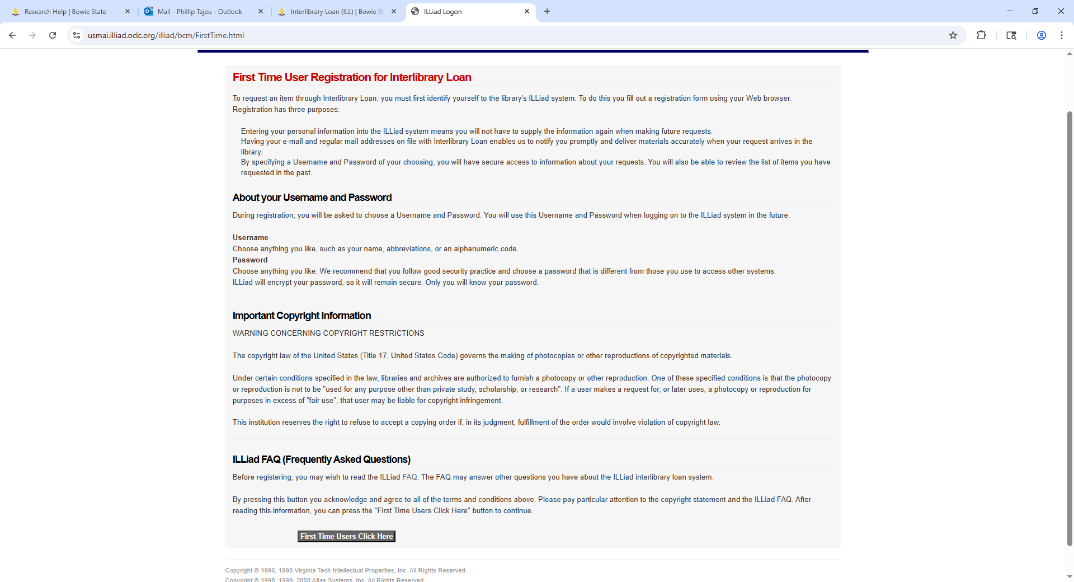
- First Time Users- fill out New User Registration for ILLiad correctly and with required information *
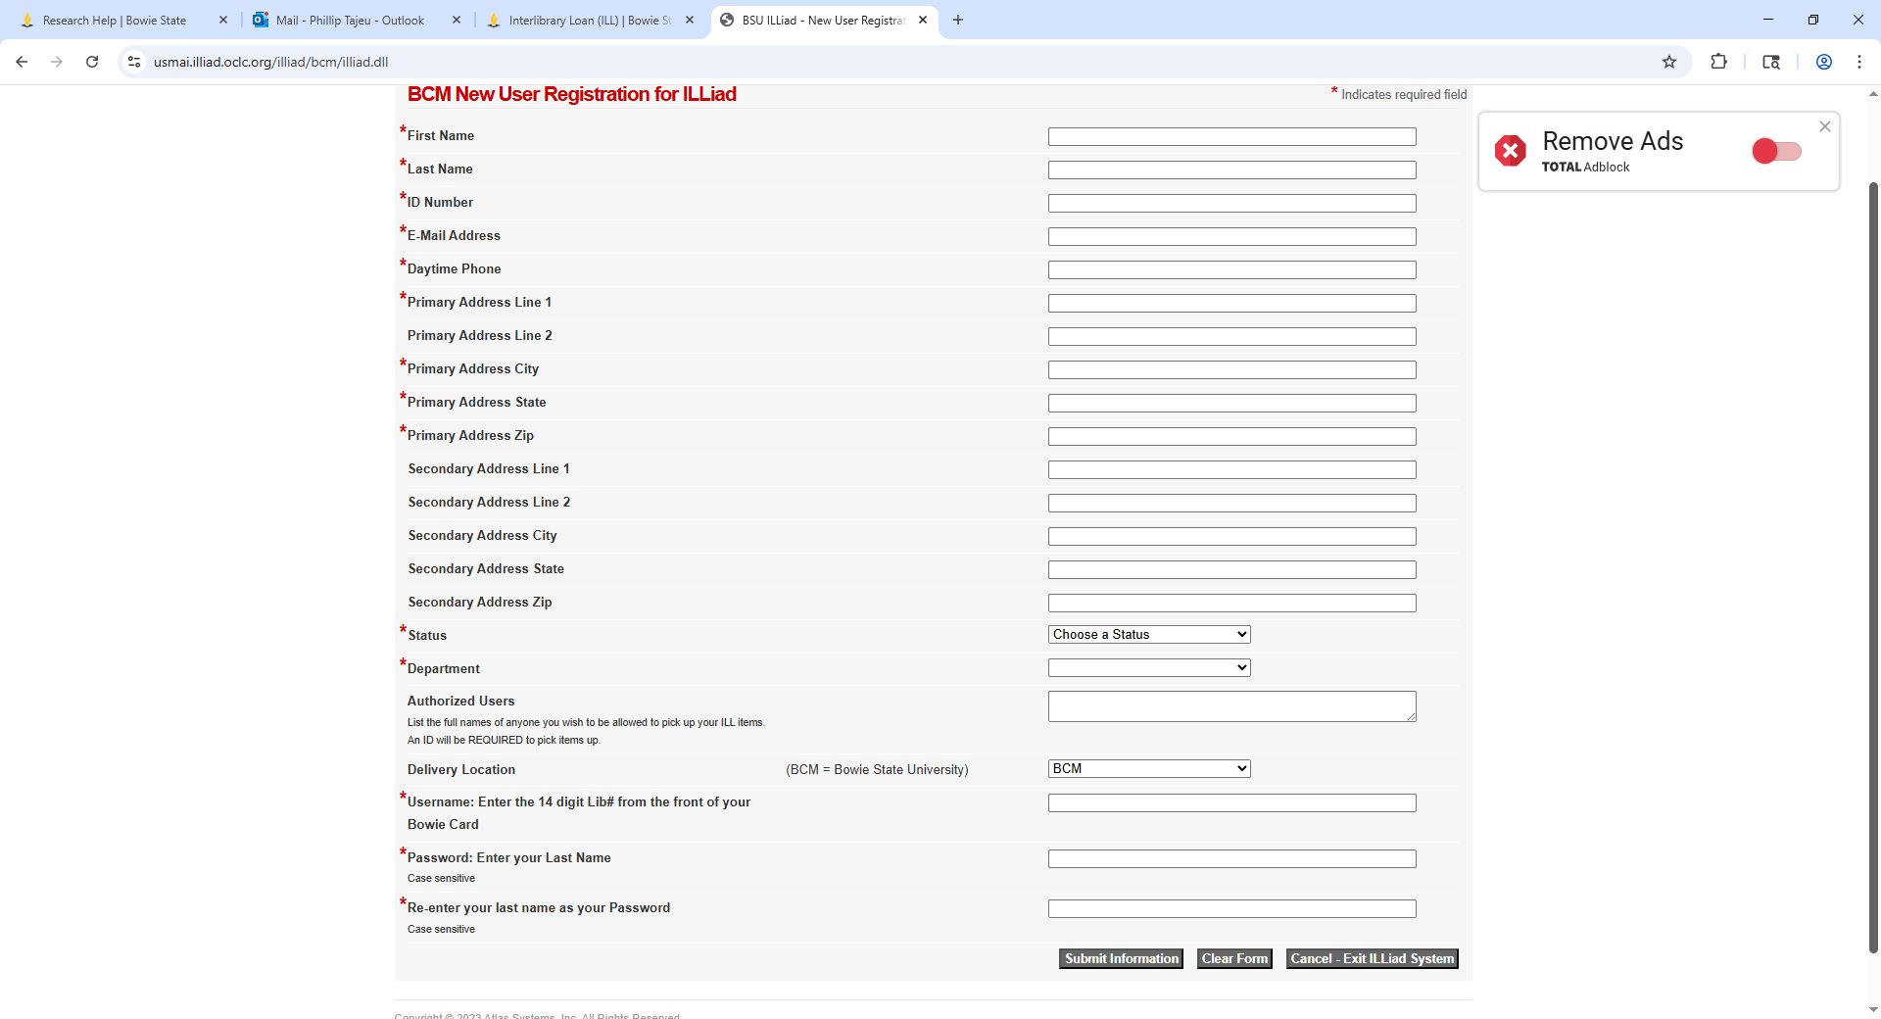
Enter the 14-digit Lib# from the front of Bowie Card
- ILLiad Account Request a scholarly journal article click on Photocopy. Provide required information
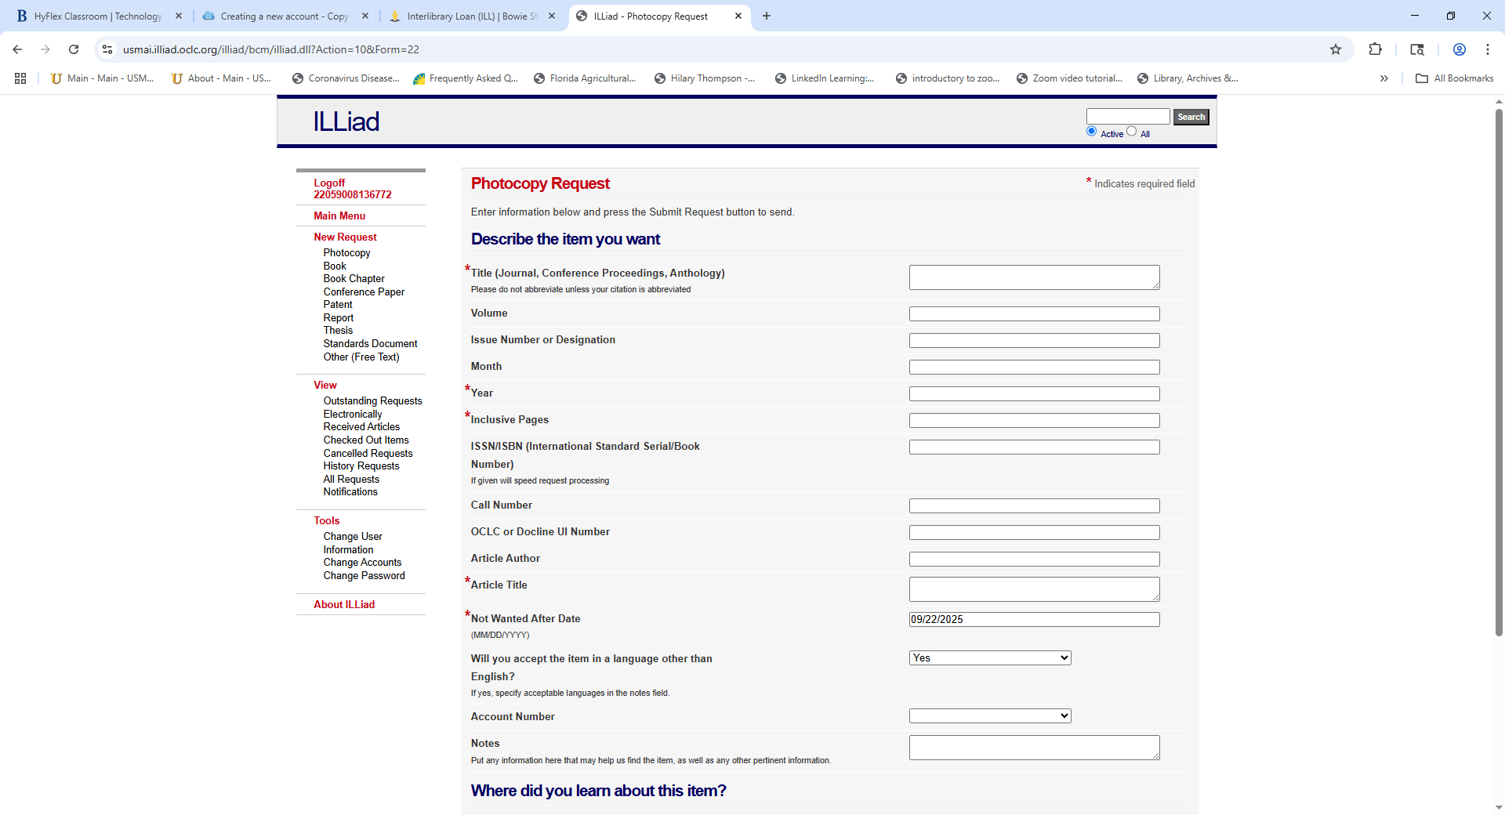
Electronically Received Articles

